In celebration of Dia De Los Muertos {Day of the Dead} many build Altares {Altars} in honor of their loved ones who have passed. An altar is a space used to place all the wonderful things that remind you of those who have passed. It consists of pictures, candles, flowers, treats, and of course yummy foods. They are considered offerings to the dead who come to visit us on this one magical day.
Our class will be doing their very own mini altars in a shoebox.
To make their own Day of the Dead Shoebox Altar they’ll need:
–Shoebox any size
–Paper or wrapping paper to cover your box
–Pictures of passed loved ones

–Items loved ones enjoyed- remember anything counts as an offering

–Candles

–Tissue flowers (flowers play a big part in the decor of an altar) We will make paper flowers in class.

–Adhesive to stick all your items

Steps:
1- Wrap your box in paper. It’s nice to use bright colors perhaps even colors your loved ones liked.
2- Place your pictures. It’s best to adhere them to the inside wall of the box. You can use popsicle sticks to create frames. It is a nice touch to decorate, but you may use anything else you’d like.
3. Place any other décor like wooden crosses, religious saint pictures and lots of hearts and gems.
4. Add other treats and foods. Anything from chocolates to chips to real food.
5. Lastly add some non-lit candles and make some tissue paper flowers.
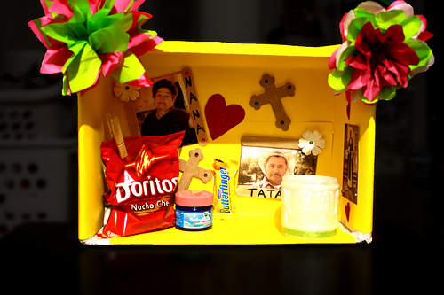

In addition to the shoebox altar, students will need to write a small descriptive paragraph describing their experience in putting together the altar and who the person/s being remembered were. Please help your child in telling them stories of the person/s being remembered. This experience is a great way to bond even more as a family and remember those loved ones who have passed.
Shoebox altars and descriptive paragraphs will be due by Tuesday, October 3oth. Students will have the opportunity to present them in class.

